

**School of Computer Science and Engineering**

**Fall Semester 2024-25**

**CAT I**

**SLOT: C2+TC2**

**Programme Name & Branch:** B.Tech [ALL branches]

**Course Name & Code:** Software Engineering & BCSE301L

**Class Number (s):** VL2024250102364

**Faculty Name (s):** Prof. P. Senthilnathan

**Exam Duration: 90 Min. Maximum Marks: 50**

1. Explain the scheduling process of a software engineering project and list few problems that may be faced in the requirement analysis phase of a software engineering project.

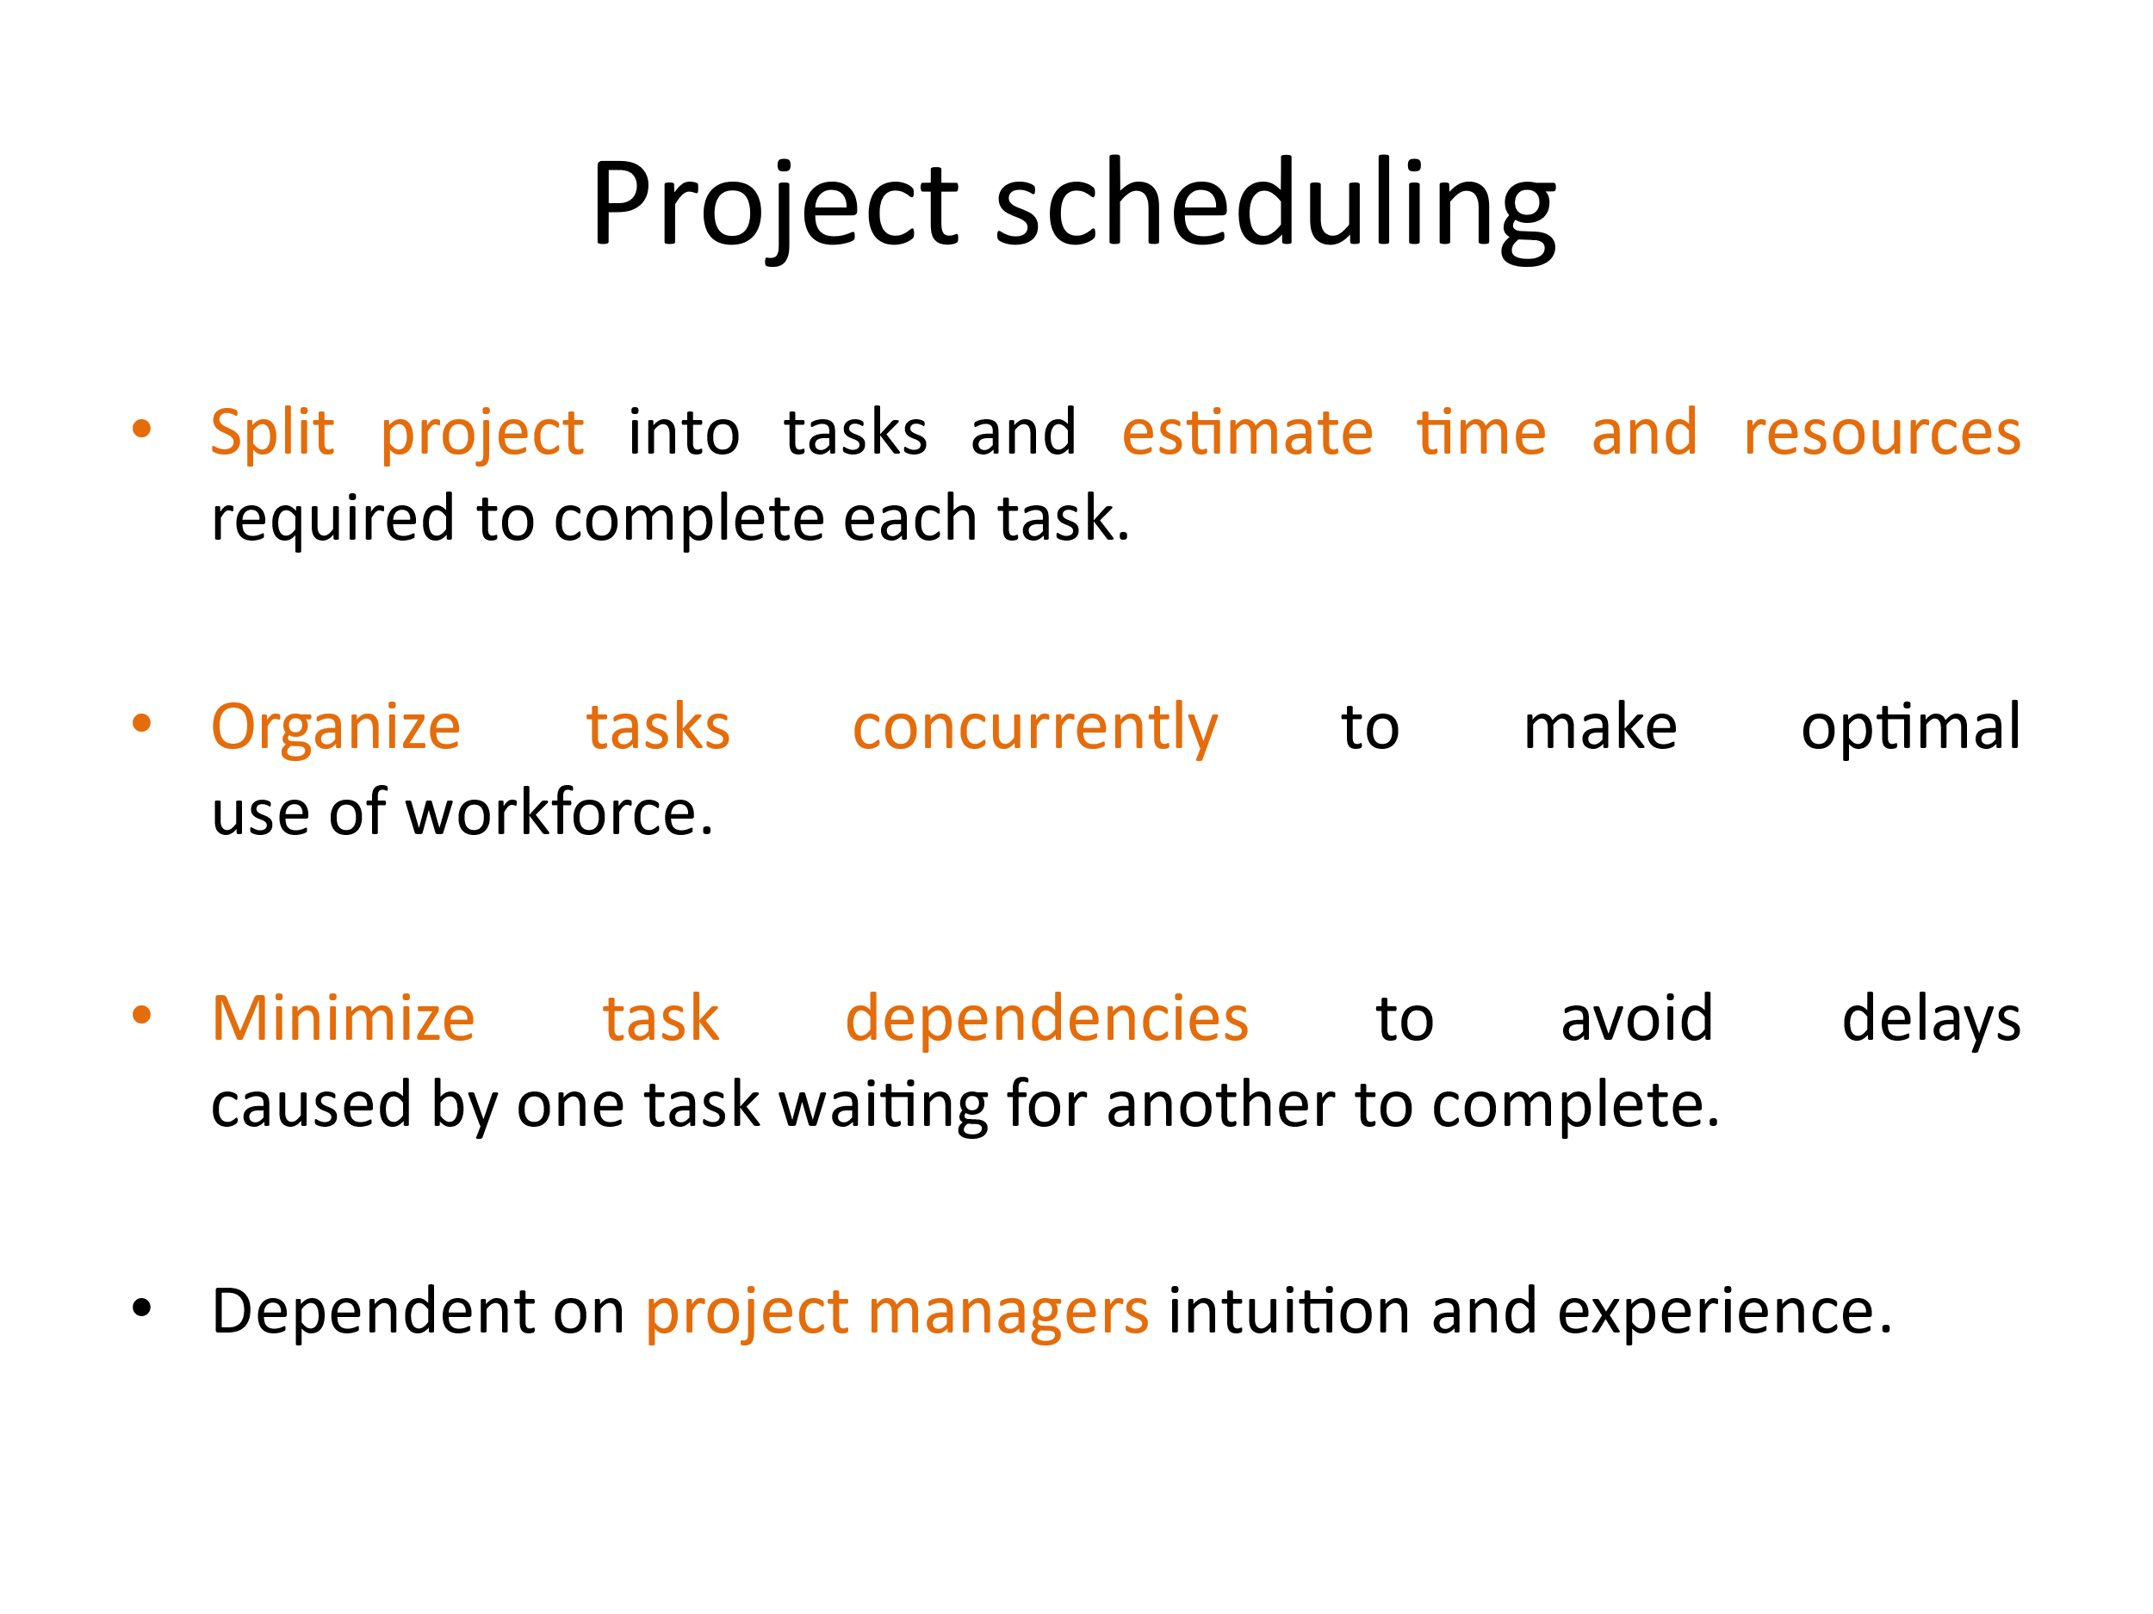

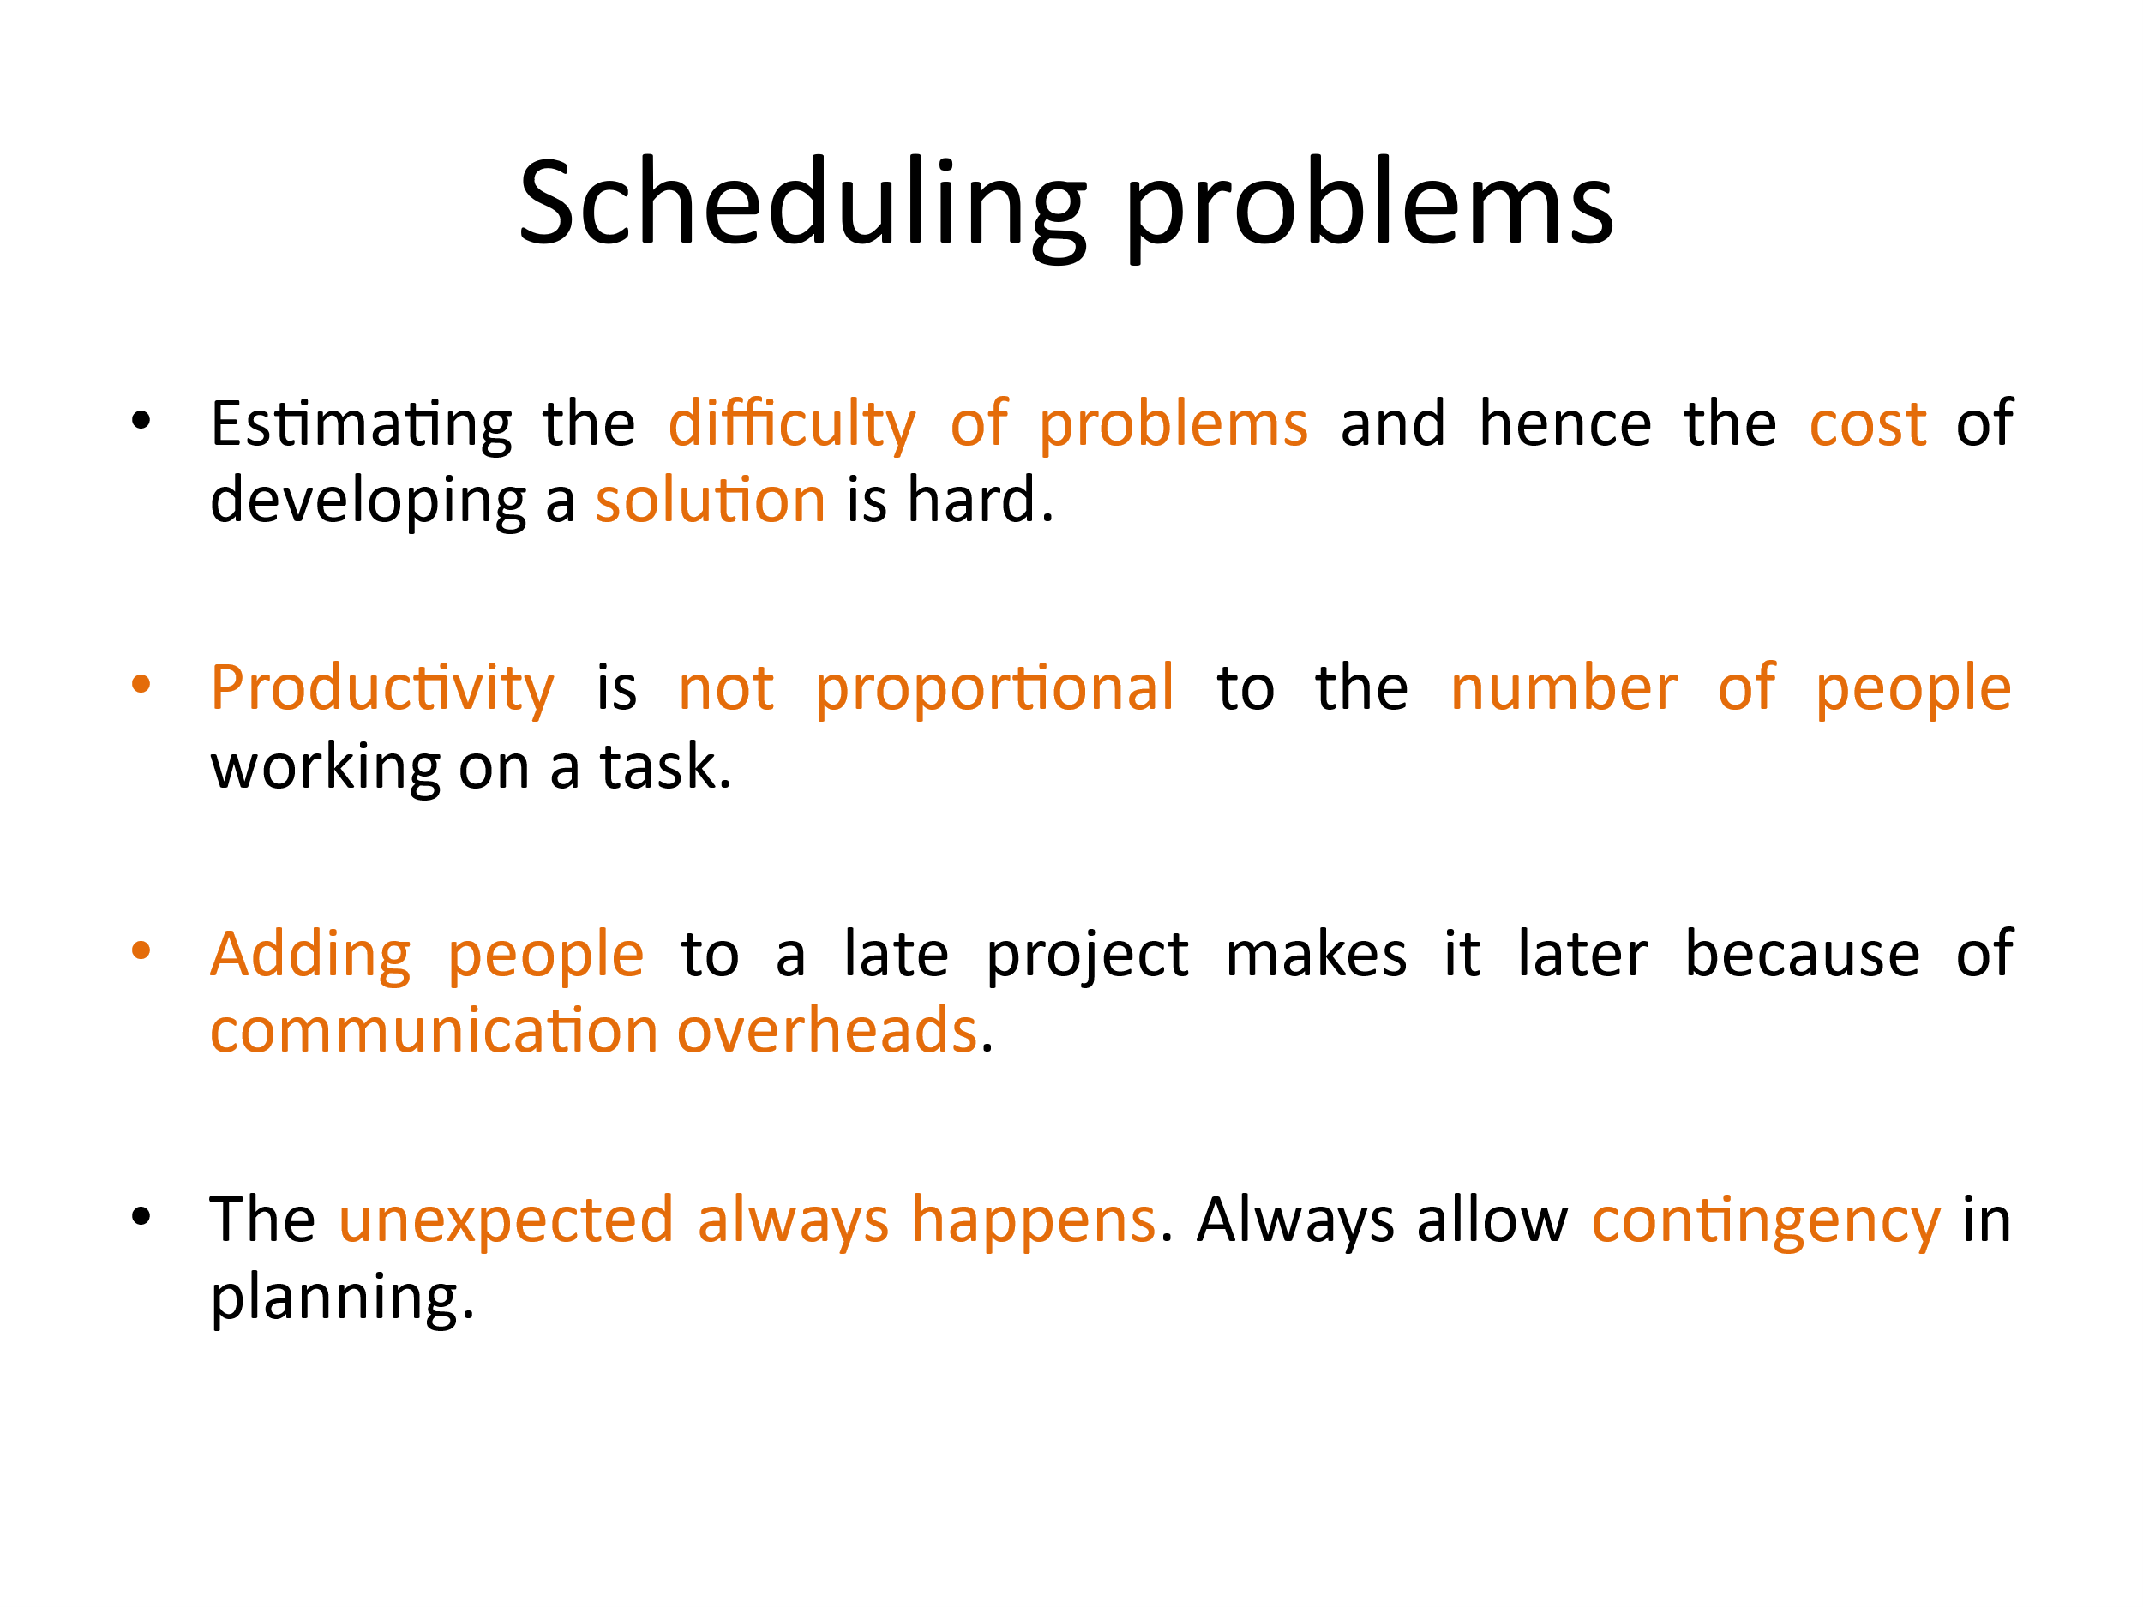

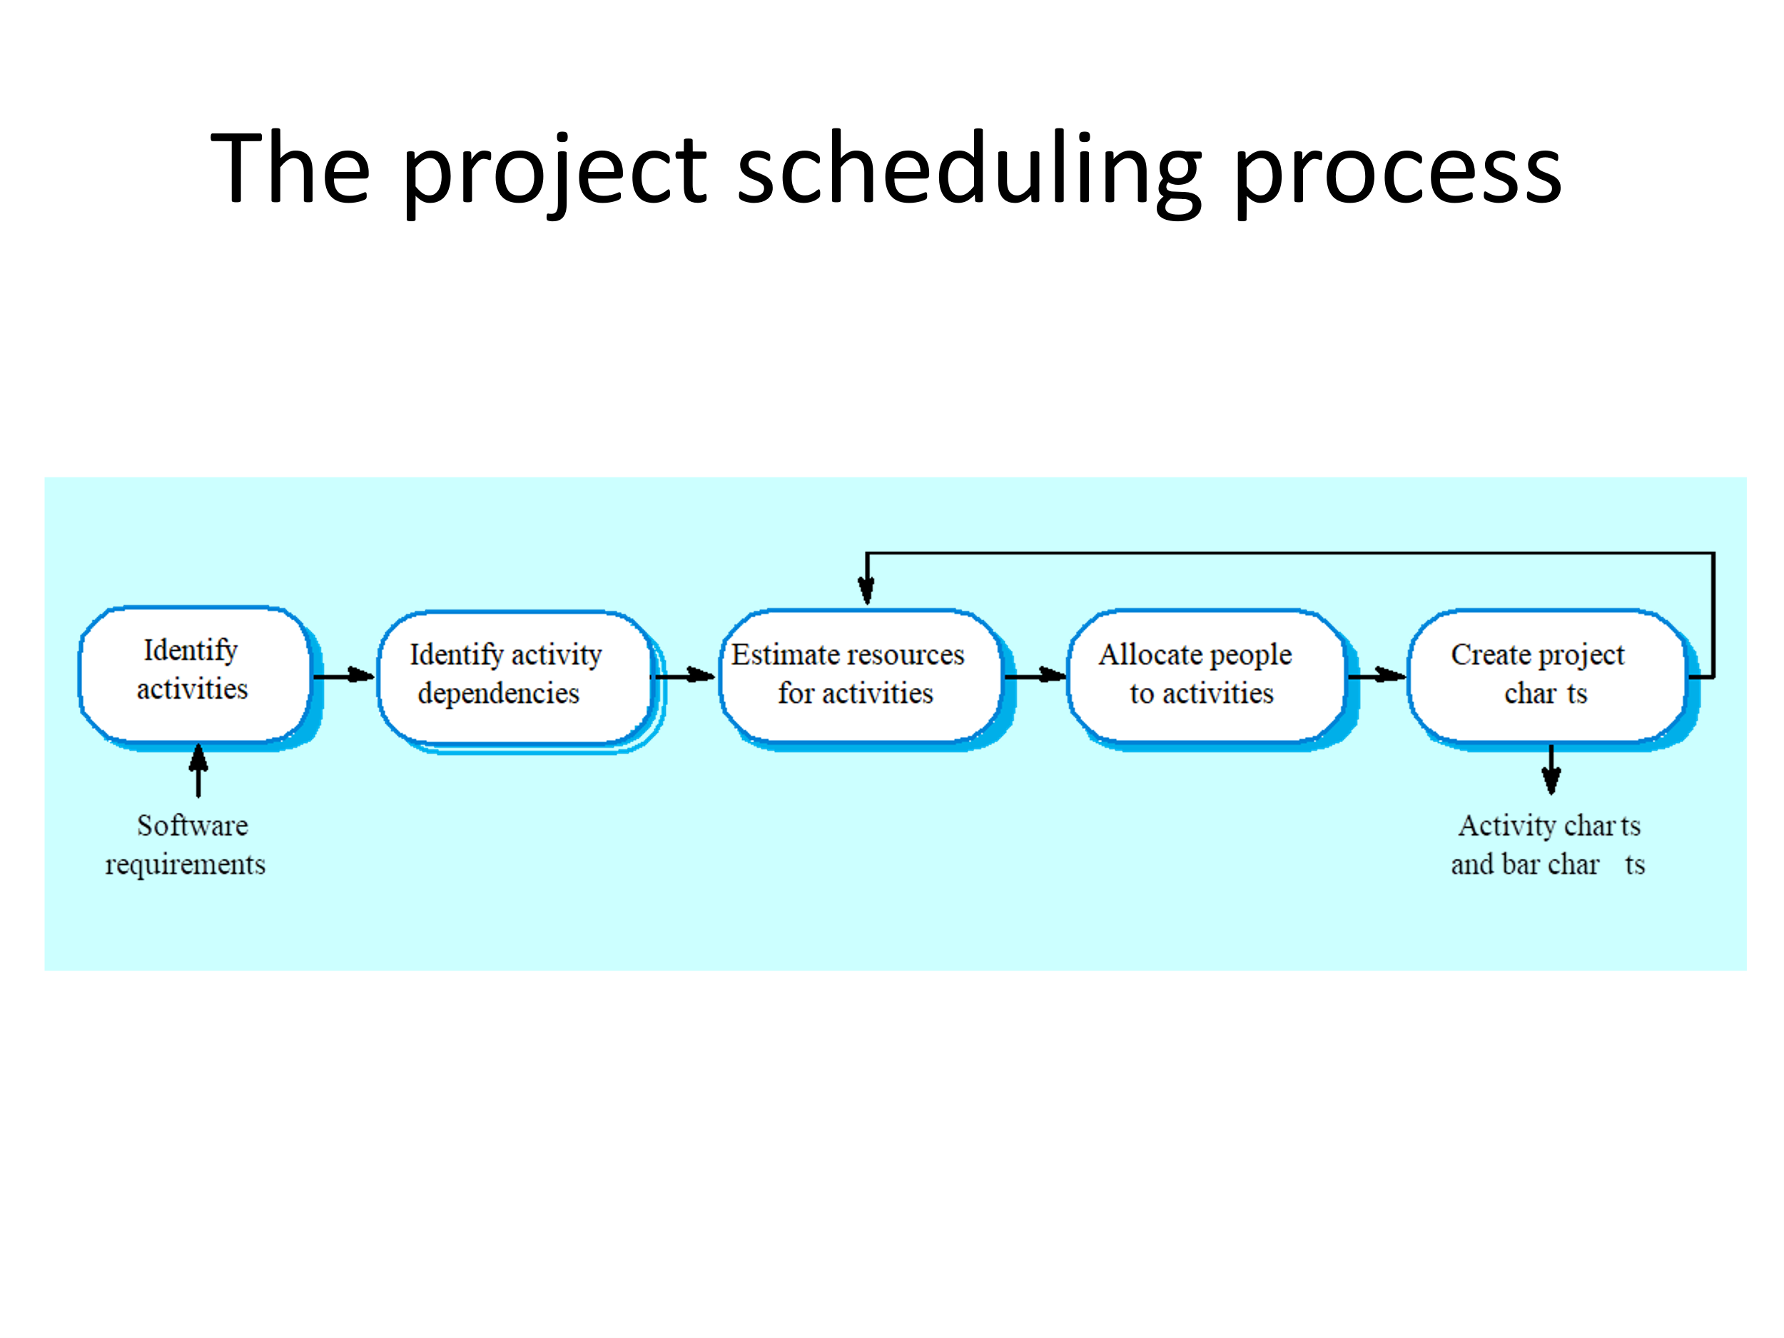

2. You have been appointed as a project manager and your job is to build a social website for encouraging the people to abstain from various pollution causatives. It works on the principles of health promotion and strengthening the society. It is not only making the users aware of the diseases caused but also how to prevent them from the same. It encourages, conducts and participates in investigations and research relating to problems of water, land and air pollution and its prevention, control and abatement thereof. Examine which non-agile software process model will suit the above scenario better. Validate your answer for choosing the model and for not choosing the other models by a wise comparison.

Incremental model. Since it is giving provision to release the application in various versions.

3. Support a prototyping model to pitch your understanding about the project which is a web application for the attendance registration of the students who have registered for the different courses in a semester of our university through a face reorganization system. So that you can get approval from the authority concern without any hassle to proceed further with the developments of this project and justify why you are supporting a particular prototyping model for the same.

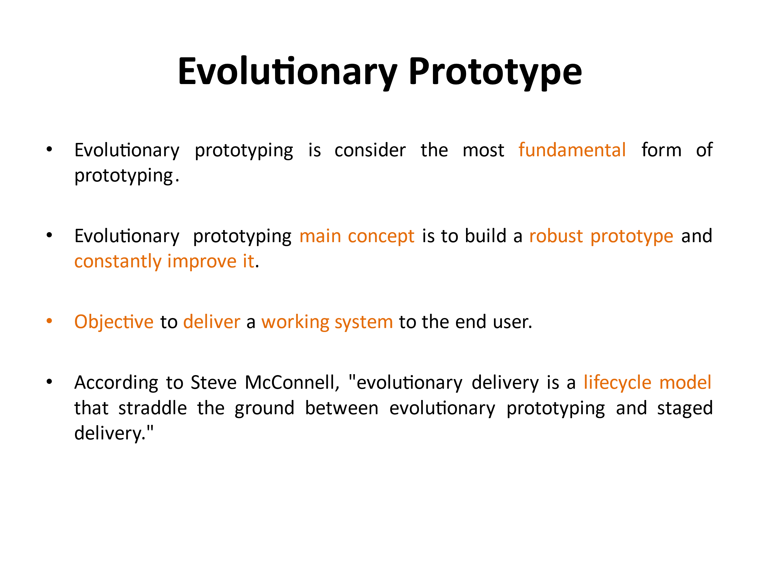

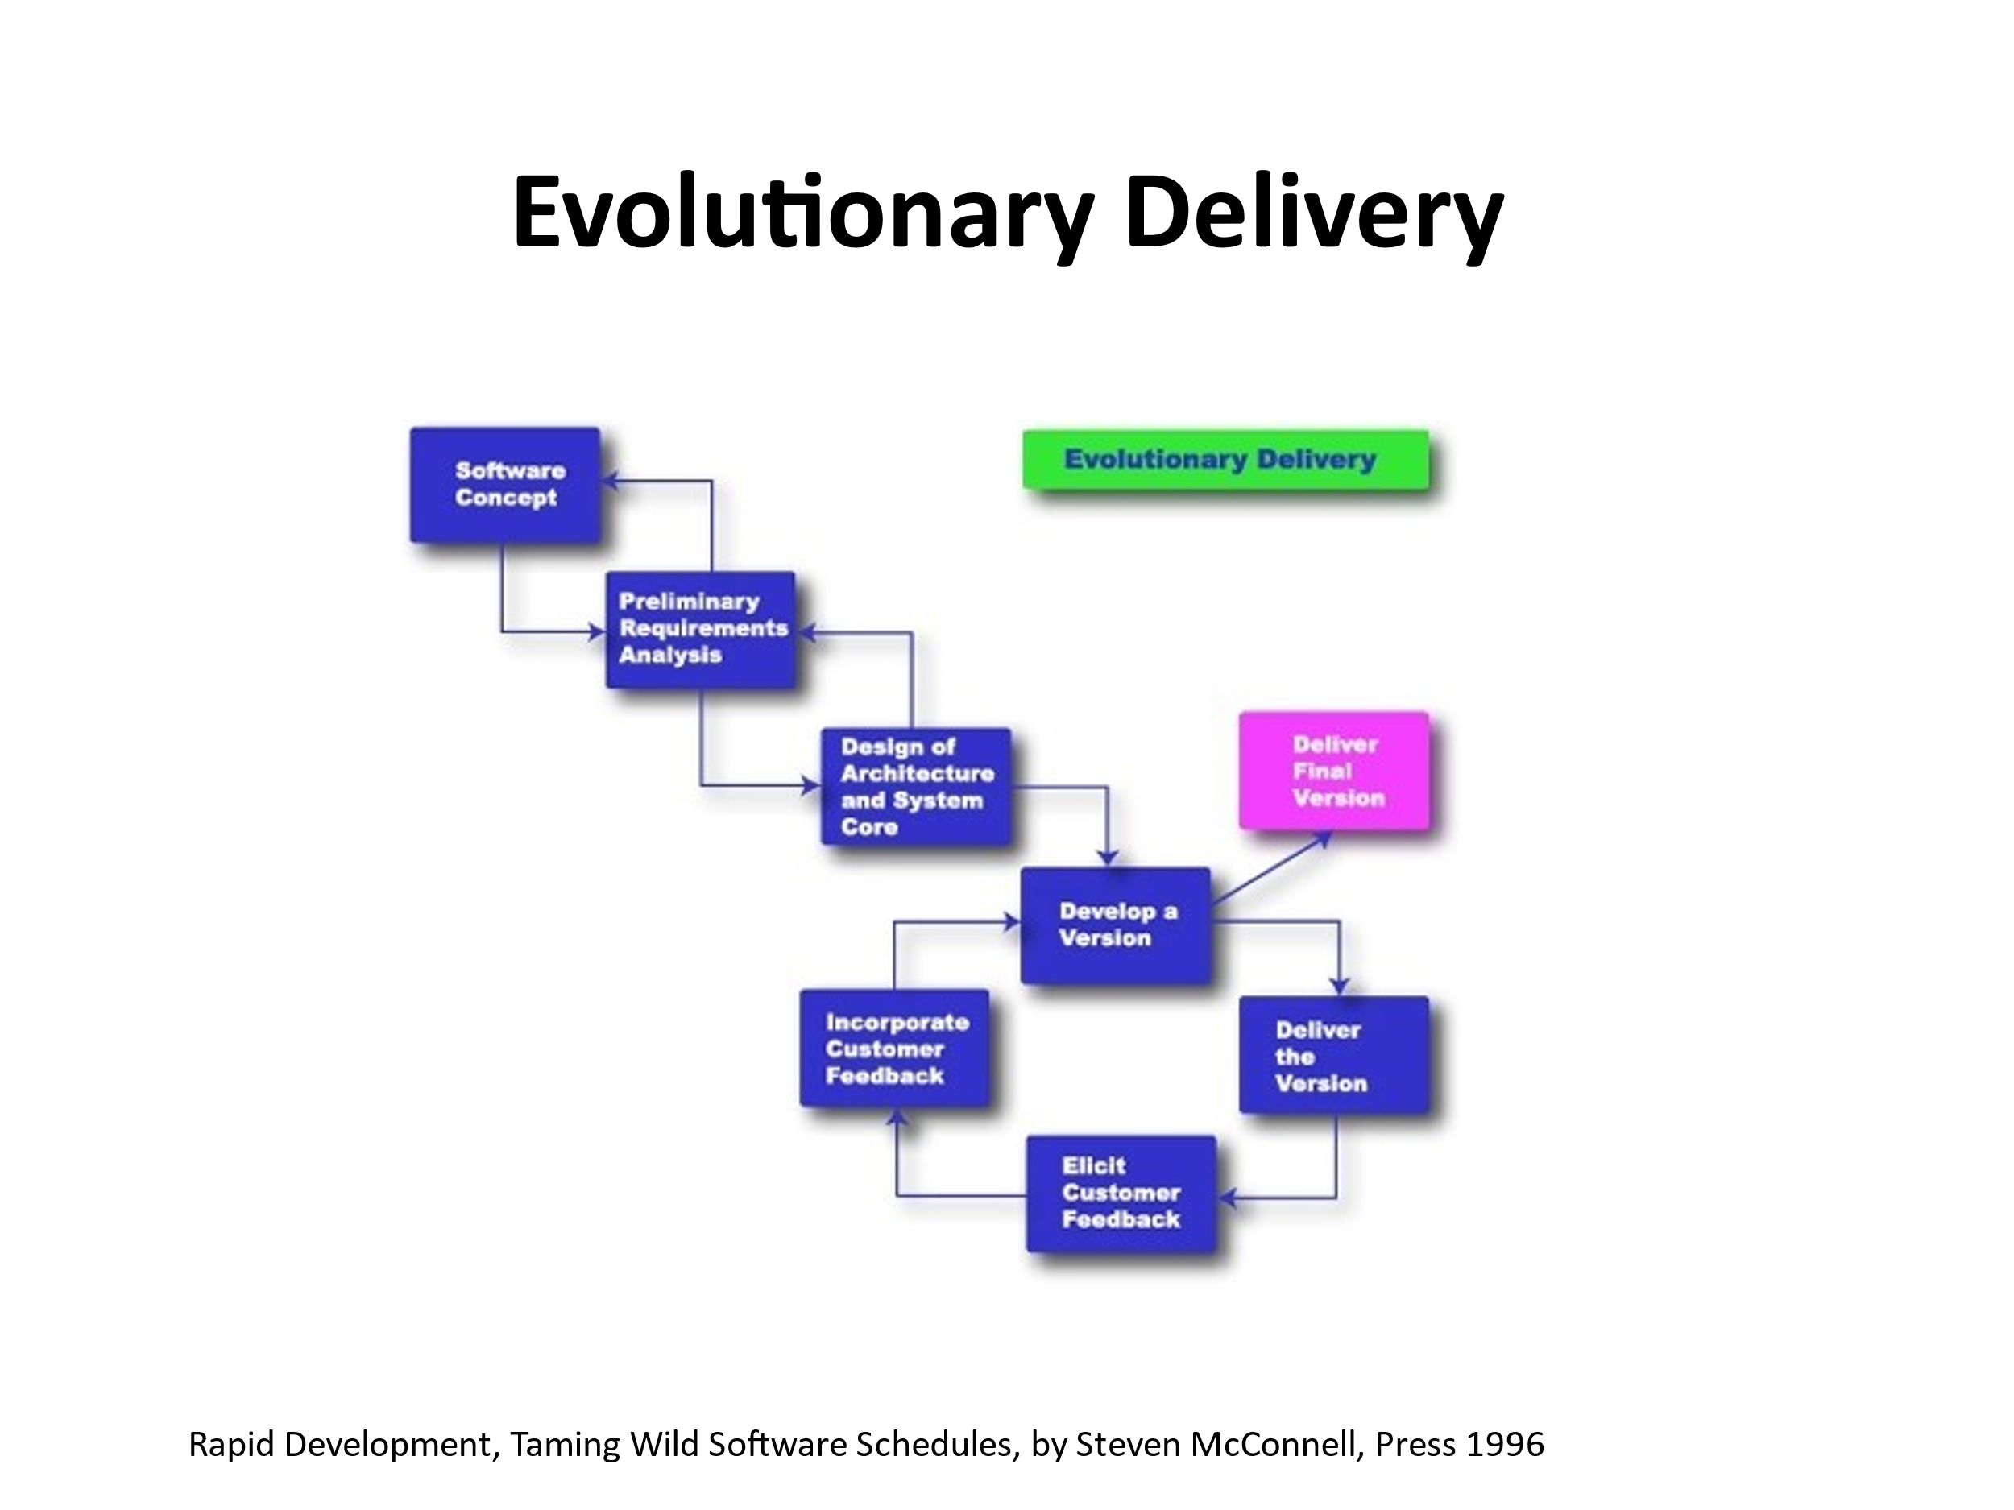

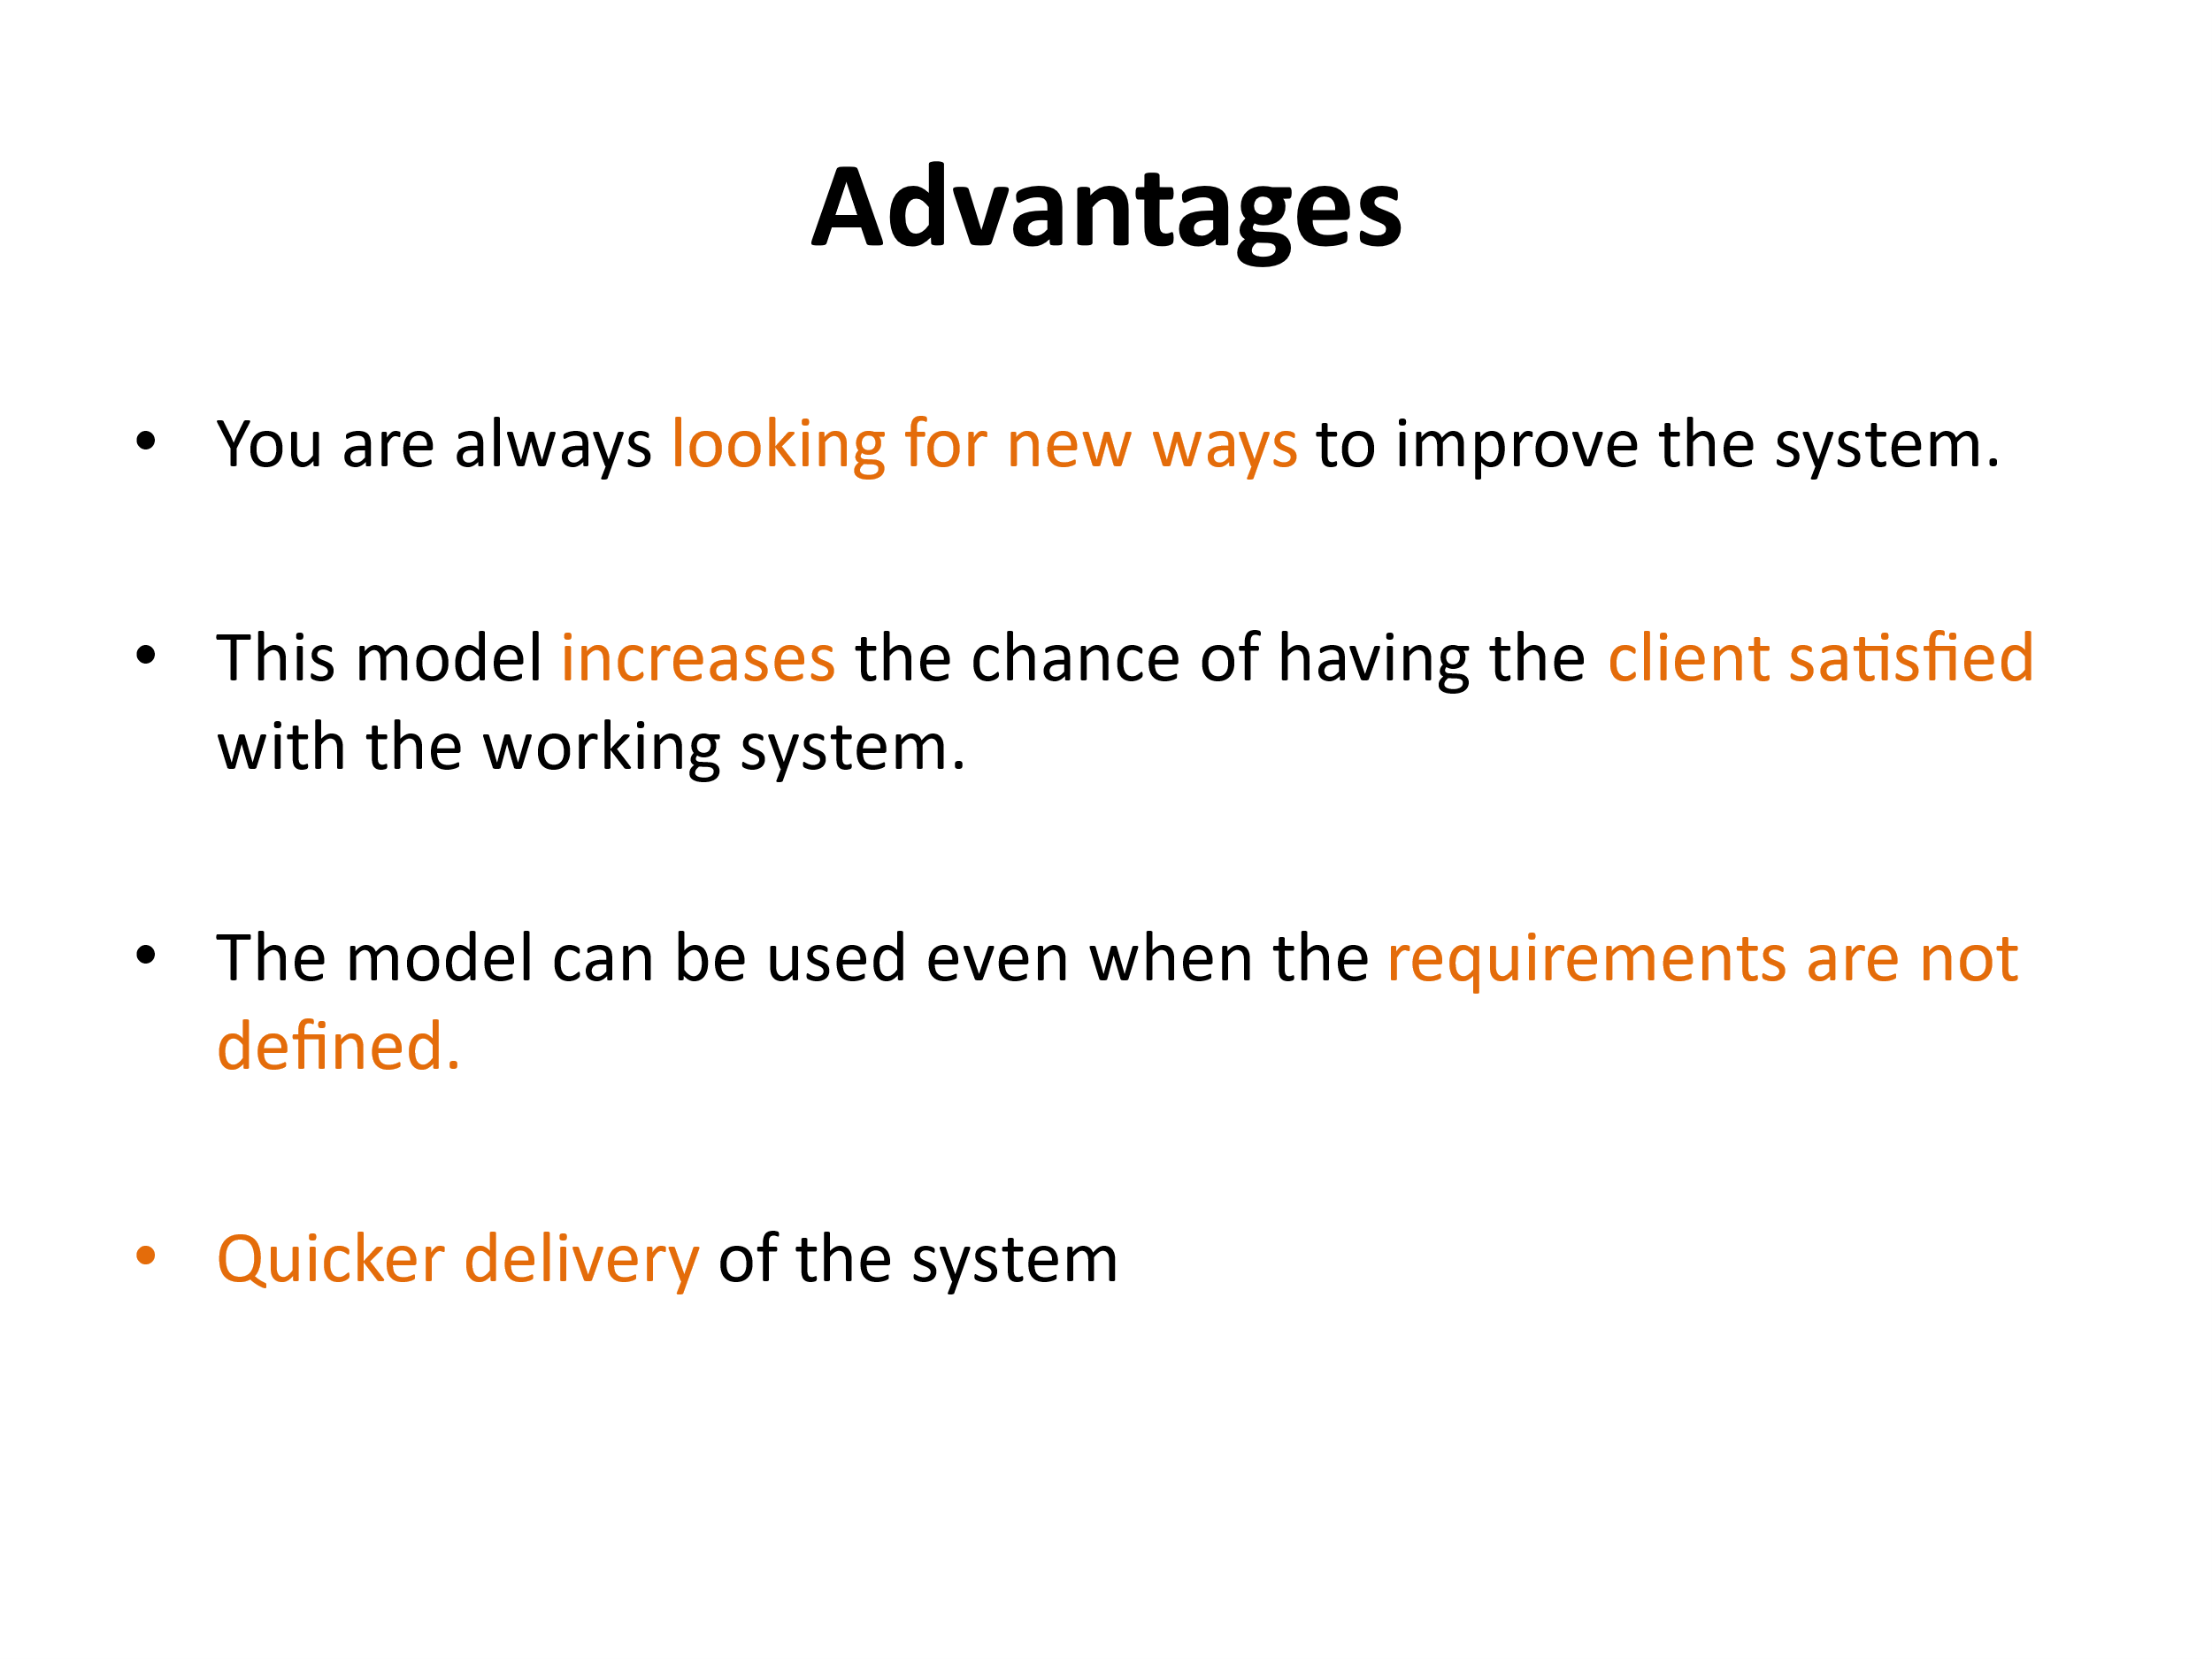

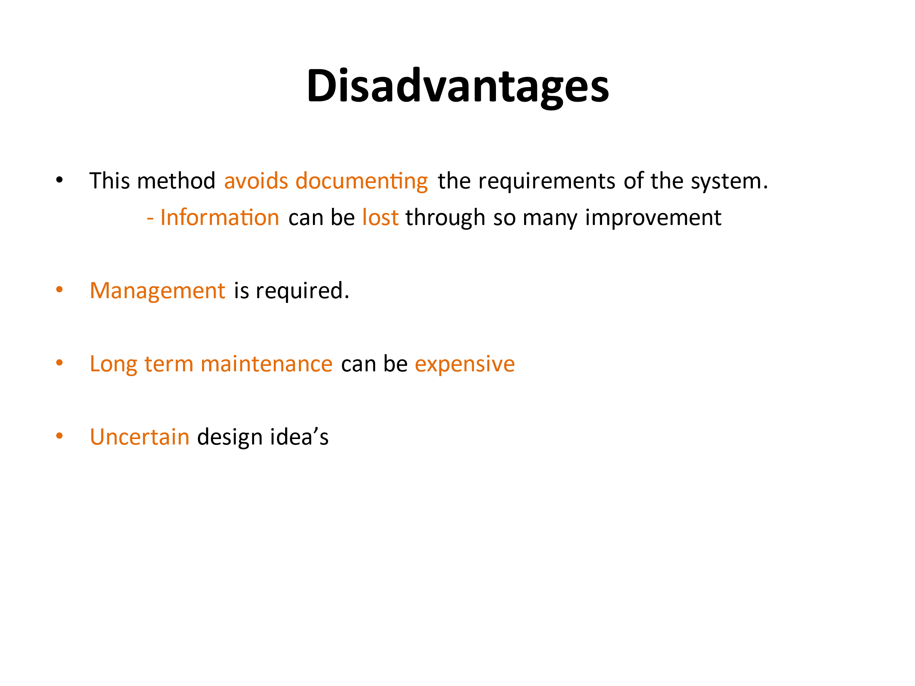

4. Develop the activity network diagram and do staff allocation for a software engineering project’s various activities and durations that are listed below.

|  |  |  |  |  |  |  |  |  |  |  |  |  |
| --- | --- | --- | --- | --- | --- | --- | --- | --- | --- | --- | --- | --- |
| Task | T1 | T2 | T 3 | T 4 | T 5 | T 6 | T7 | T 8 | T 9 | T 10 | T11 | T 12 |
| Duration | 08 | 15 | 15 | 10 | 10 | 05 | 20 | 25 | 15 | 15 | 7 | 10 |
| Dependency | - | - | T1 | - | T2,T4 | T1,T2 | T1 | T4 | T3,T6 | T5,T7 | T9 | T 11 |

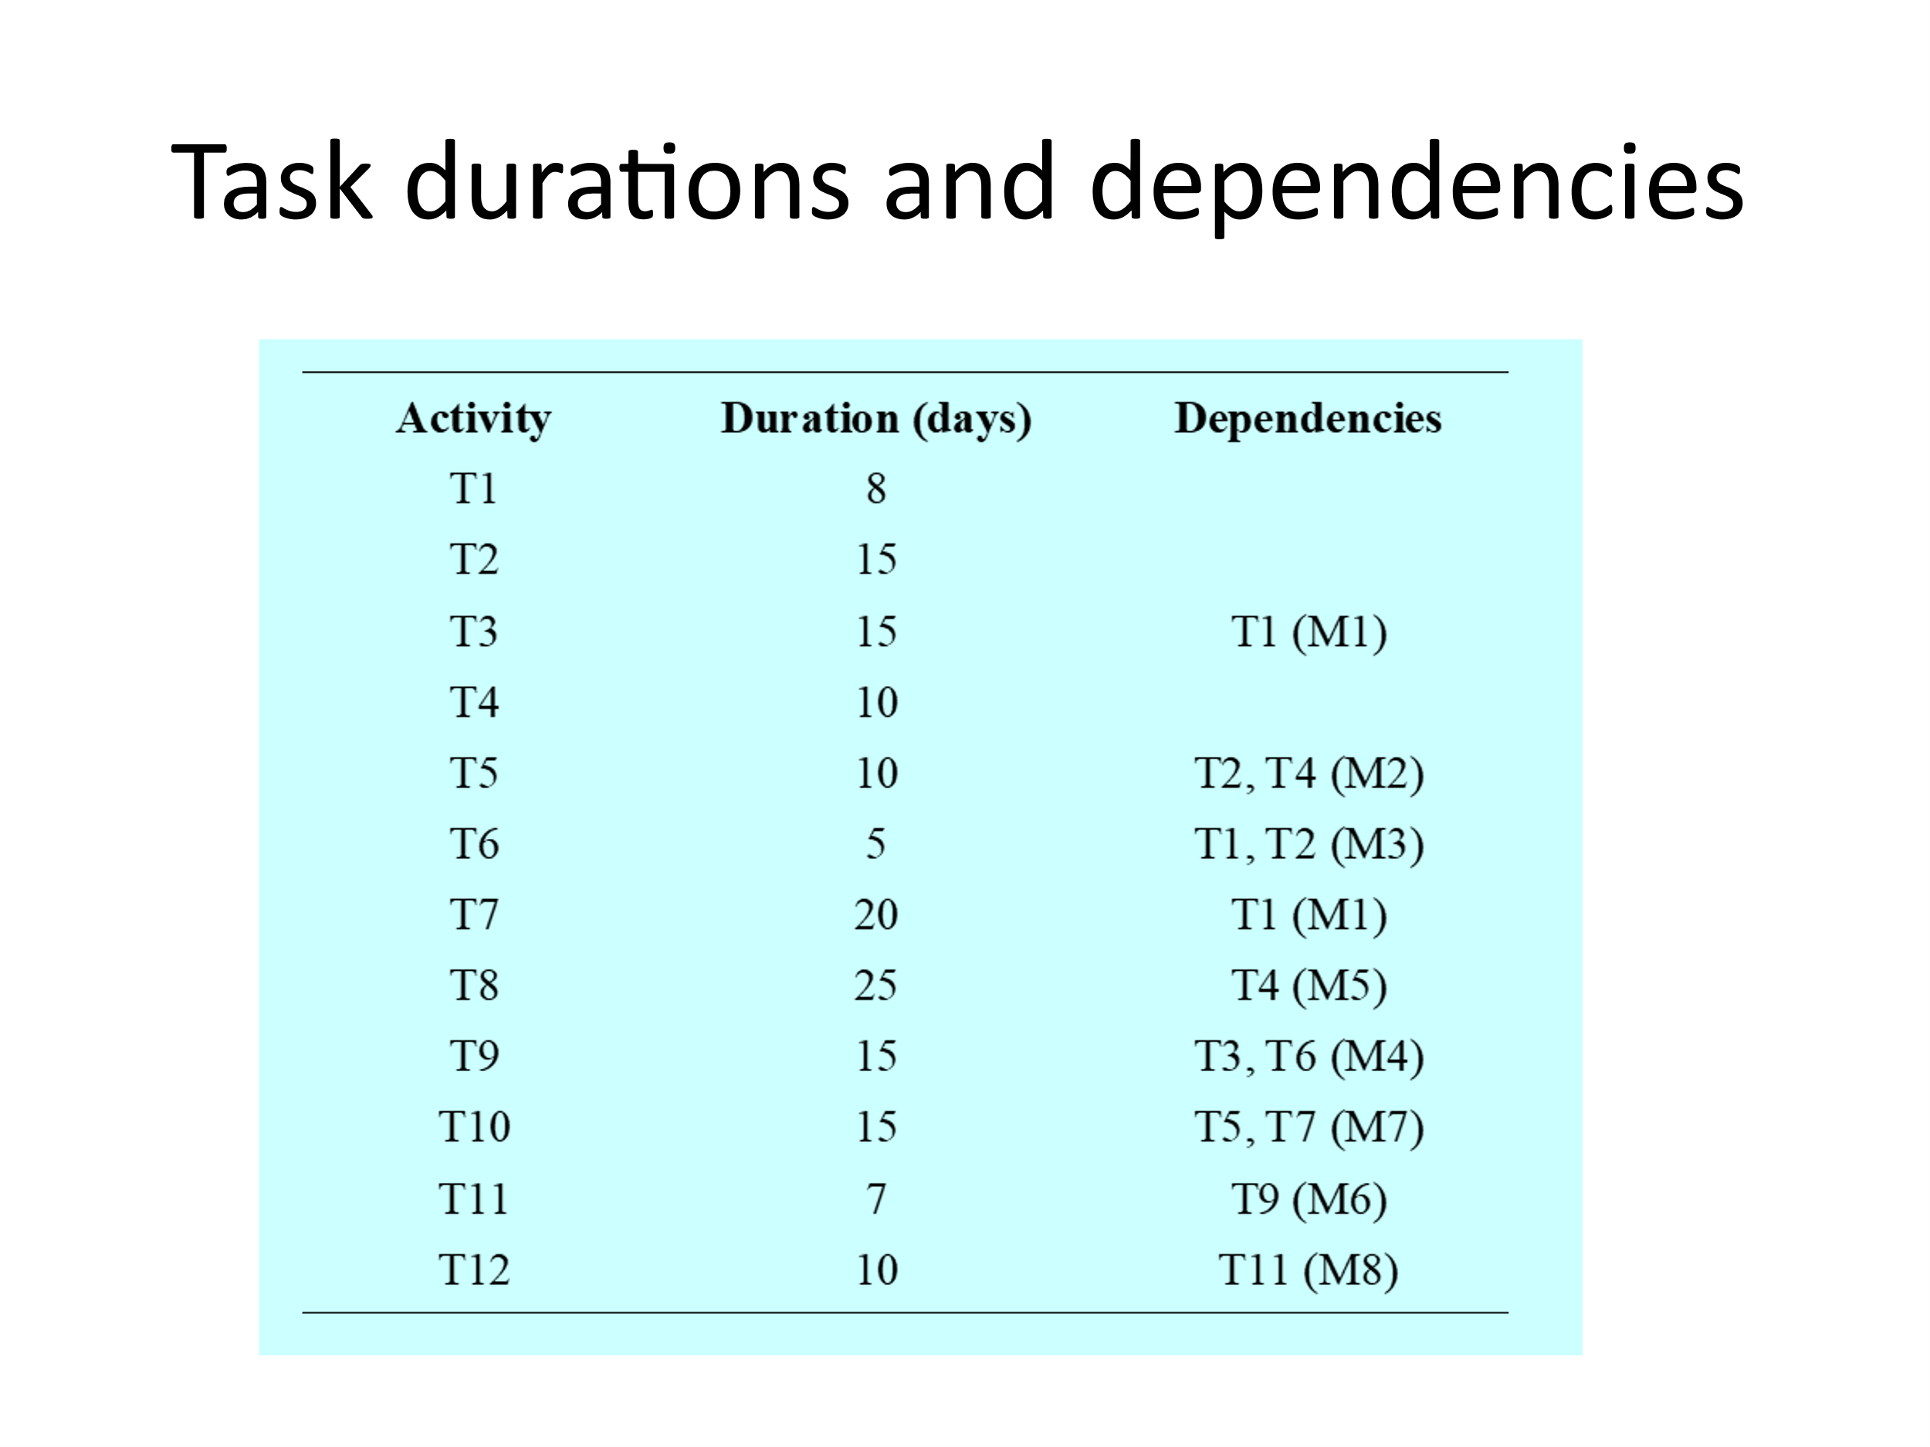

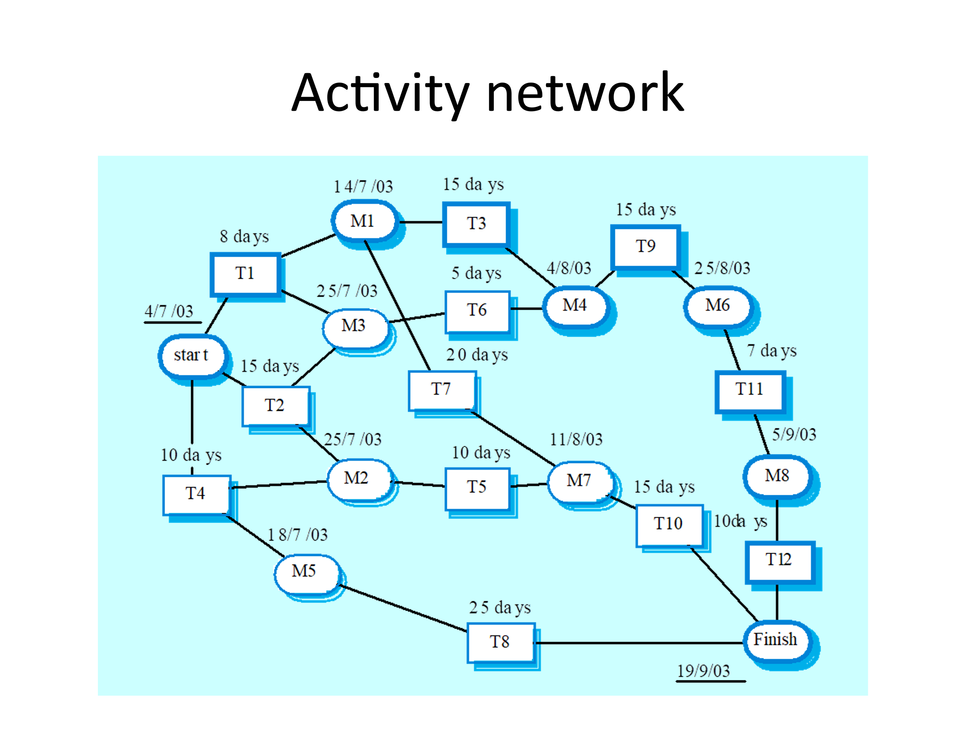

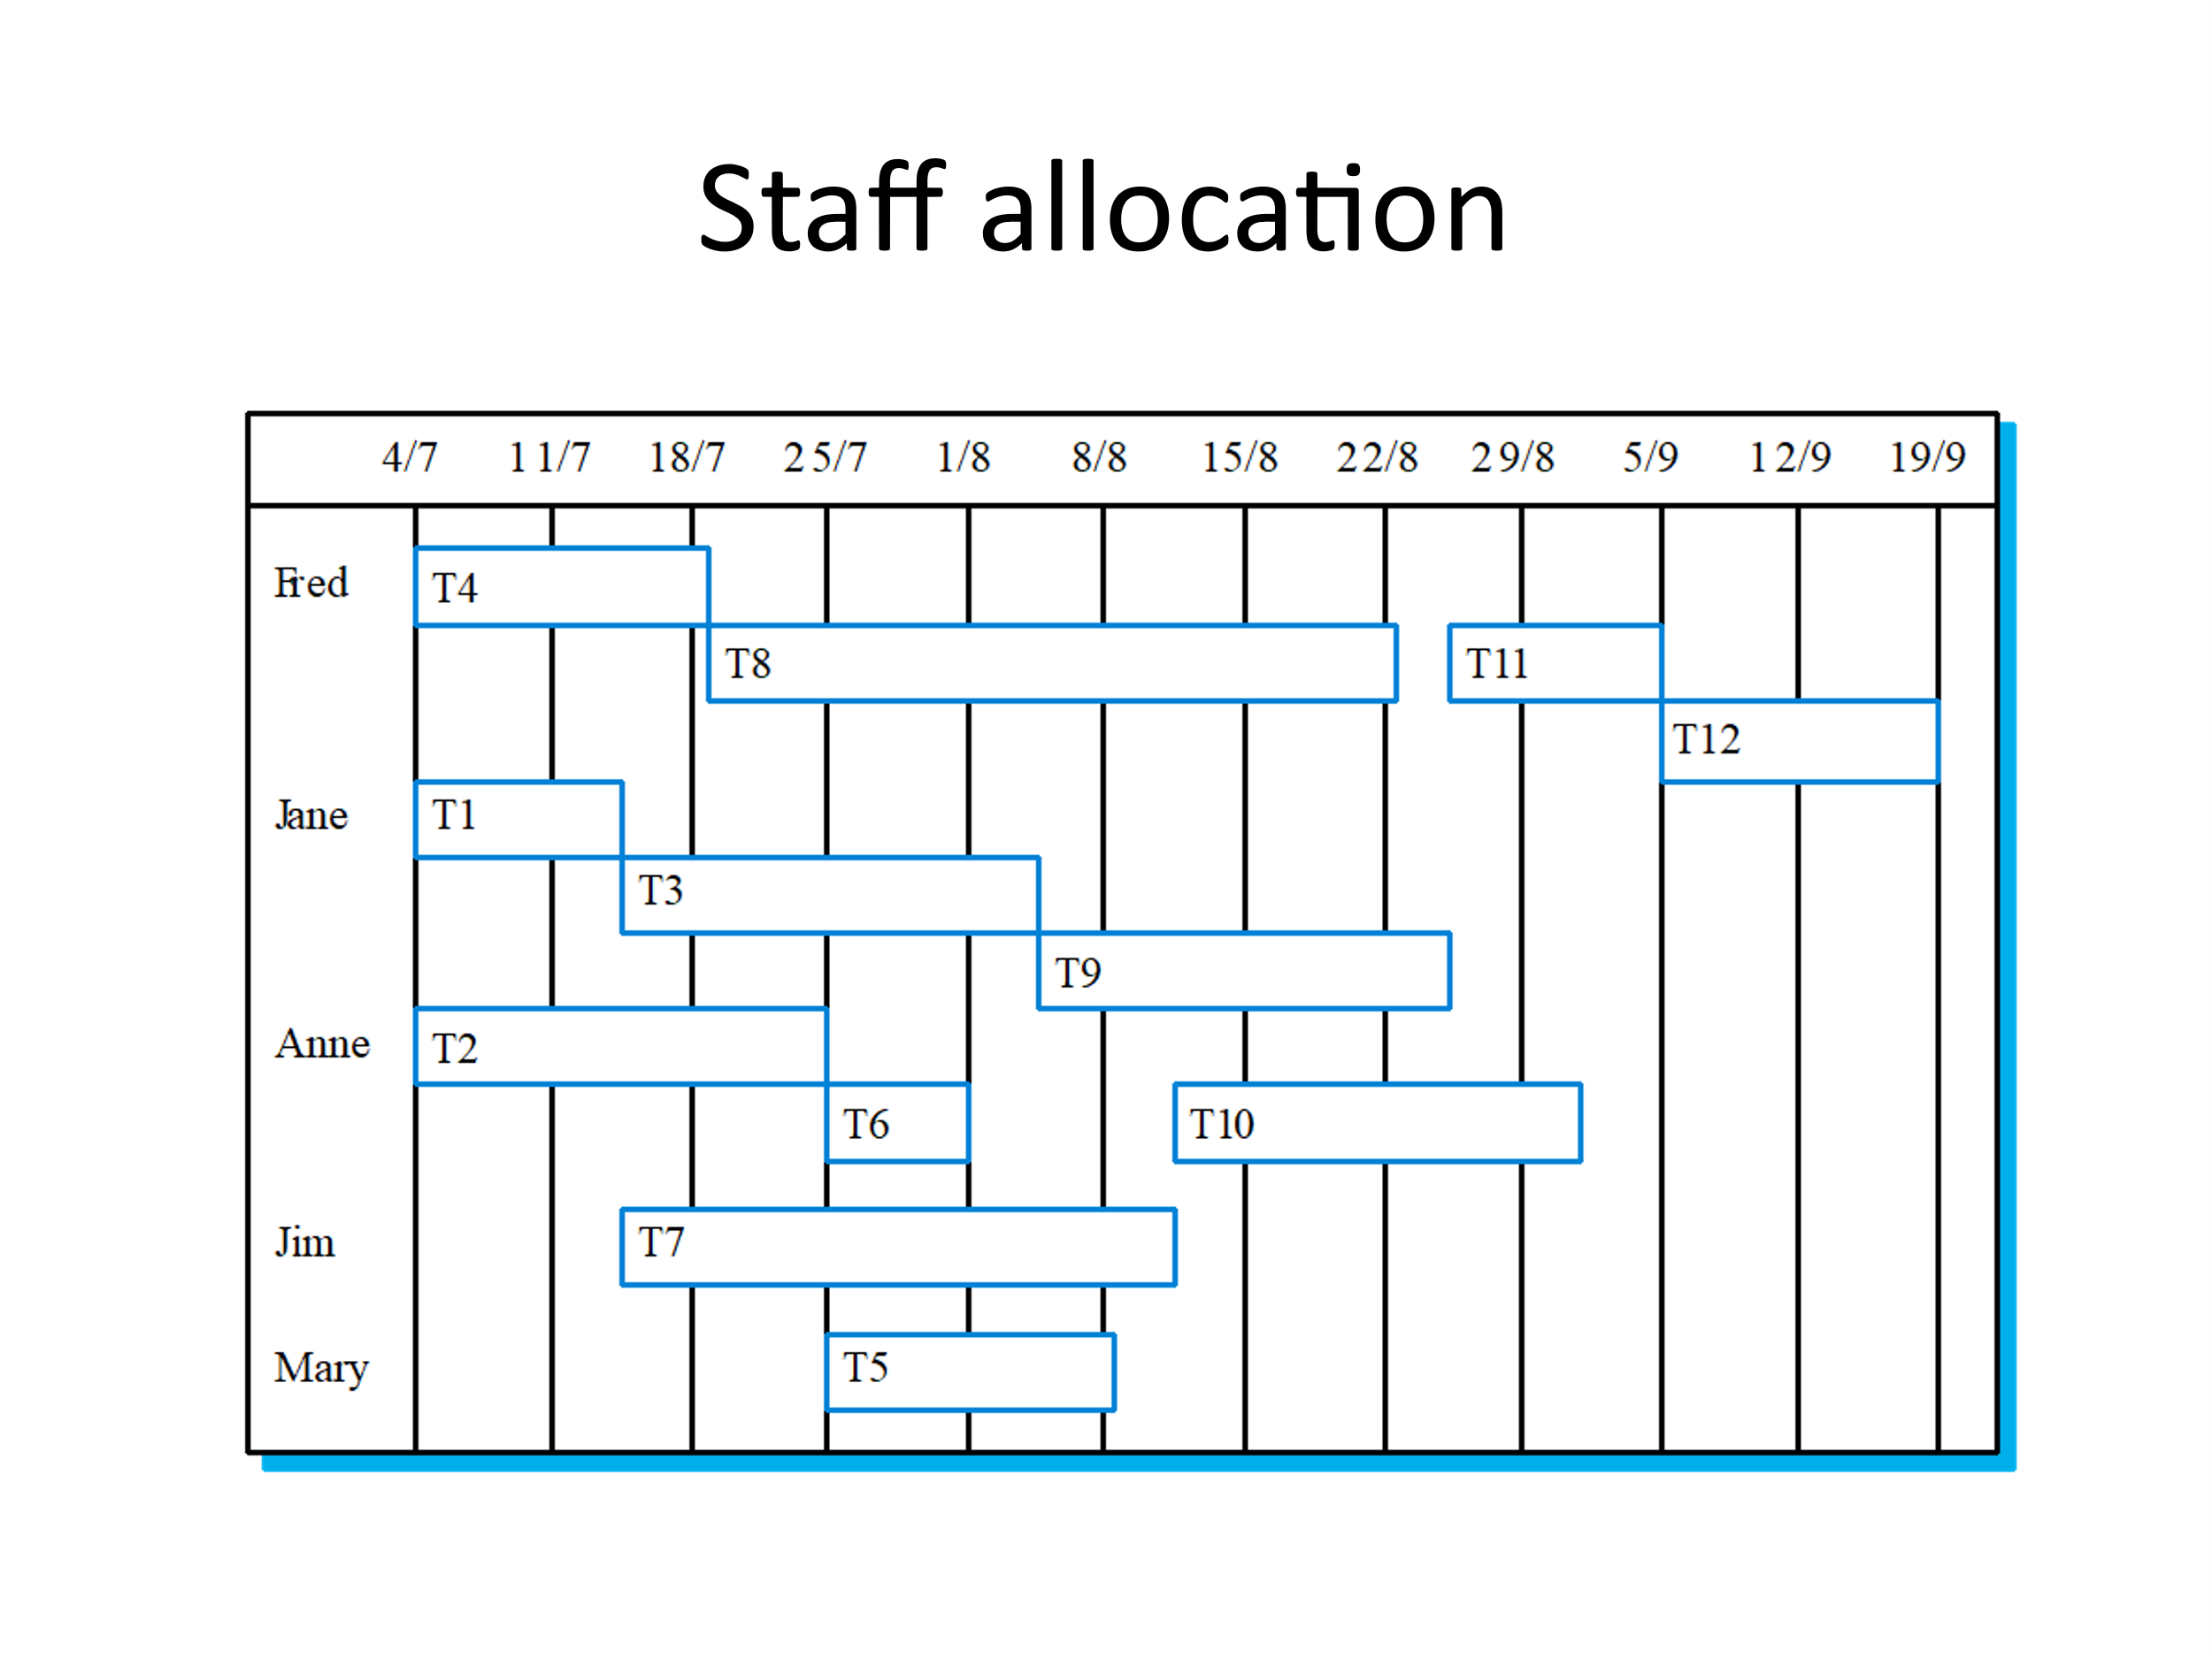

5. Consider the ERP solution developing project for an automobile spare parts manufacturing company and perform the following

1. Identify both user requirements and system requirements. (both functional requirements and system software application requirements)

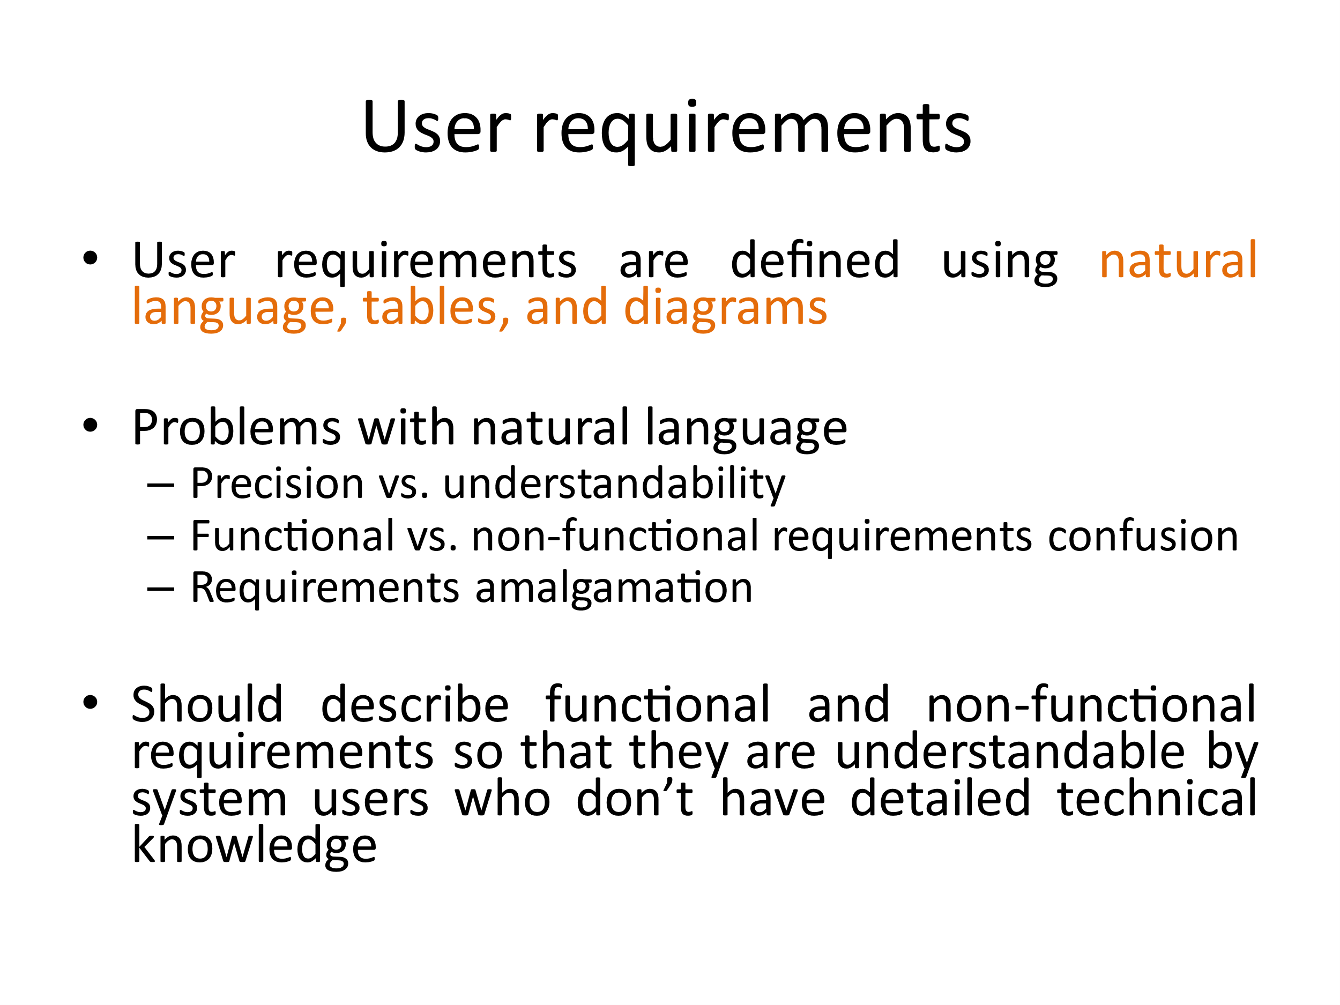

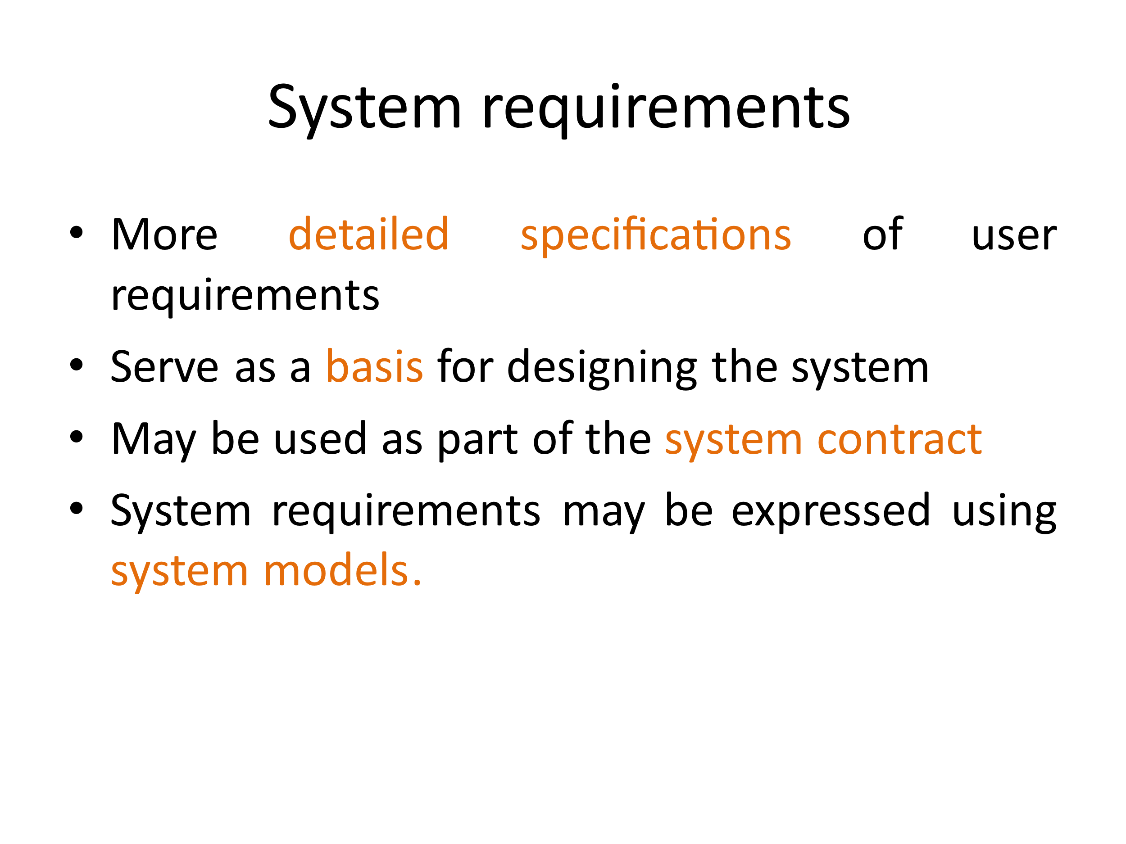

2. Identify the stakeholders. (Administrator, unit manager, supplier, competitors, investors, banks …etc)